**PROJECT REPORT**

**INTODUCTION:**

* OVERVIEW:

The “Creating Dynamic Resumes/CVs using Canva” project aims to develop a comprehensive guide and toolkit for crafting visually appealing and impactful resumes/CVs using the popular graphic design tool, Canva. In today’s competitive job market, having a well-designed and professional- looking resume/CV can significantly enhance an applicant’s chances of standing out to potential employers.

* PURPOSE:

The purpose of creating a resume in Canva is that, it helps to present our qualifications in a visually appealing and compelling way, increasing the chances of making a positive impression on potential employers during the job application process.

**DESIGN THINKING:**

* EMPATHY MAP:

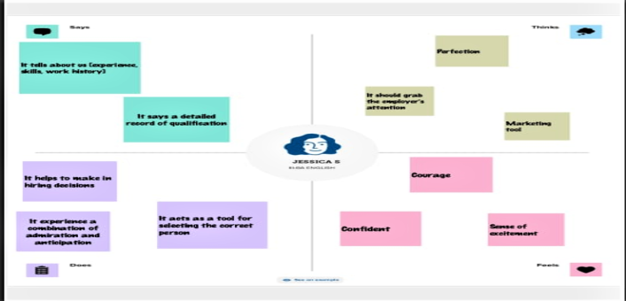

* BRAINTROMING:

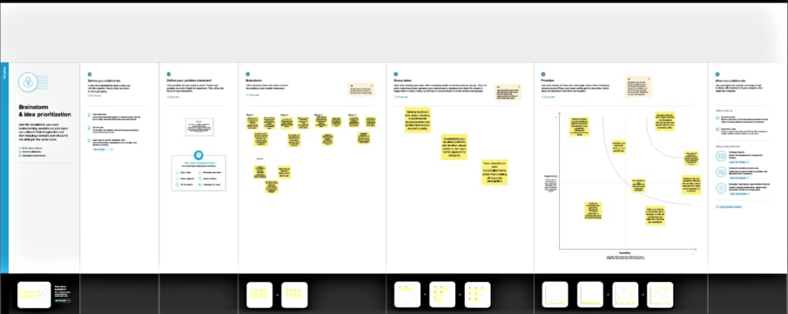

**RESULT:**

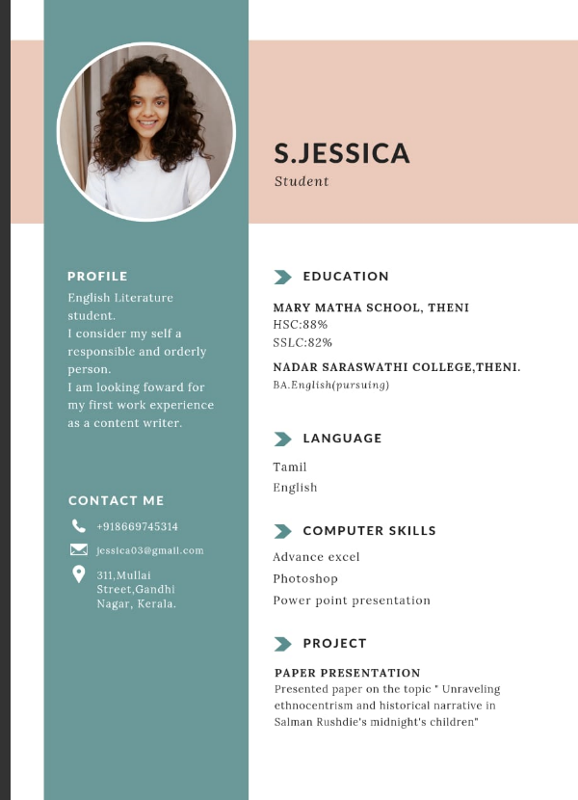

**ADVANTAGES:**

* It is easy to use, making it accessible for those with limited design experience.
* It offers a variety of professionally designed resume templates that can help your resume stand out.

**DISADVANTAGES:**

* As it is widely used, our resume might look similar to others who use the same templates.
* It’s design tools are not as advanced as dedicated graphic design software, which may limit our creativity**.**

**APPLICATION:**

* Canva's user-friendly design tools and templates make it a versatile platform for creating a wide range of professional documents.

**CONCLUSION:**

Canva has thousands of templates for Resume/CV creations and it can be particularly useful for jobs in creative fields, like graphic design, where an attractive and customized design can make a strong impression.